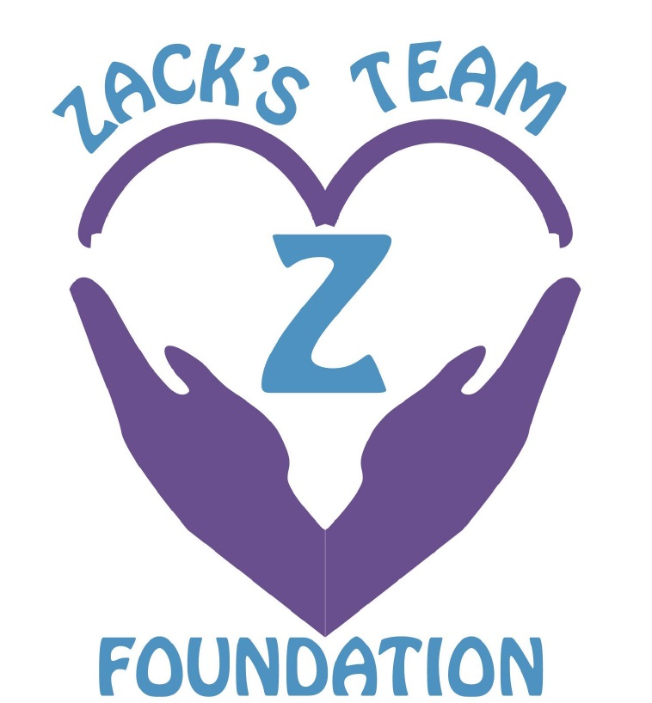

SPONSORSHIP OPPORTUNITIES

Tuesday, August 20, 2019

Please join us for our 2019 Golf Tournament!

Dear Friend,

Thanks to you, critical funds have been raised to provide 200 young adults with treatment and sober living scholarships totaling over $300,000! Thanks to you, we are able to provide a safe, structured living environment, for young adults seeking to break the chains of addiction.

These funds mean so much and help provide life-saving treatment for friends and family members that suffer from substance use disorder … and it’s all because of you. If you participate in our 6th Annual Links fore Recovery Tournament, you can feel good knowing you are playing a direct role in supporting the addiction community and helping end this devastating disease once and for all.

We will be hosting our *6th Annual Links fore Recovery Golf Tournament* on Tuesday, August 20, 2019 at Four Oaks Country Club in Dracut, Massachusetts. We will be the only tournament of the day! This fun-filled event includes lunch, 18 holes of scramble-style golf, raffles and an awards dinner following the tournament.  
We hope you will help us by sponsoring the event, providing a raffle donation, or participating in the day’s activities. We thank you in advance for your vital support – we can and will continue restoring the lives of young adults struggling with substance use disorder. Thank you for being a part of Zack’s Team.

Please review the enclosed sponsorship level opportunities and contact Taylor Alongi at 978-996-1071 or at [zacksteam818@gmail.com](mailto:zacksteam818@gmail.com) if you are interested in providing additional support for this worthy cause.

**Recovery Champion - $5,000**

* 2 Foursomes
* 2 tee signs
* Lunch/Dinner signage
* Advertisement on website

**Recovery Ambassador - $2,500**

* 1 Foursome
* 1 tee signs
* Event signage
* Advertisement on website

**Recovery Ally – Beverage Cart - $1,000**

* Two golfers
* Signage on beverage cart

**Recovery Ally – Lunch Sponsor - $1,000**

* Two golfers
* Signage at check-in

**Recovery Ally - Dinner Sponsor - $1,000**

* Table of 10 for Dinner Only
* Signage at each table

**Triple Tee Sponsor - $500**

* 3 tee signs

**Tee Sponsor - $250**

* 1 tee sign

**Friend of Zack - $100**

* Signage at event

**Donated Raffle Item**

* Acknowledgement on signage

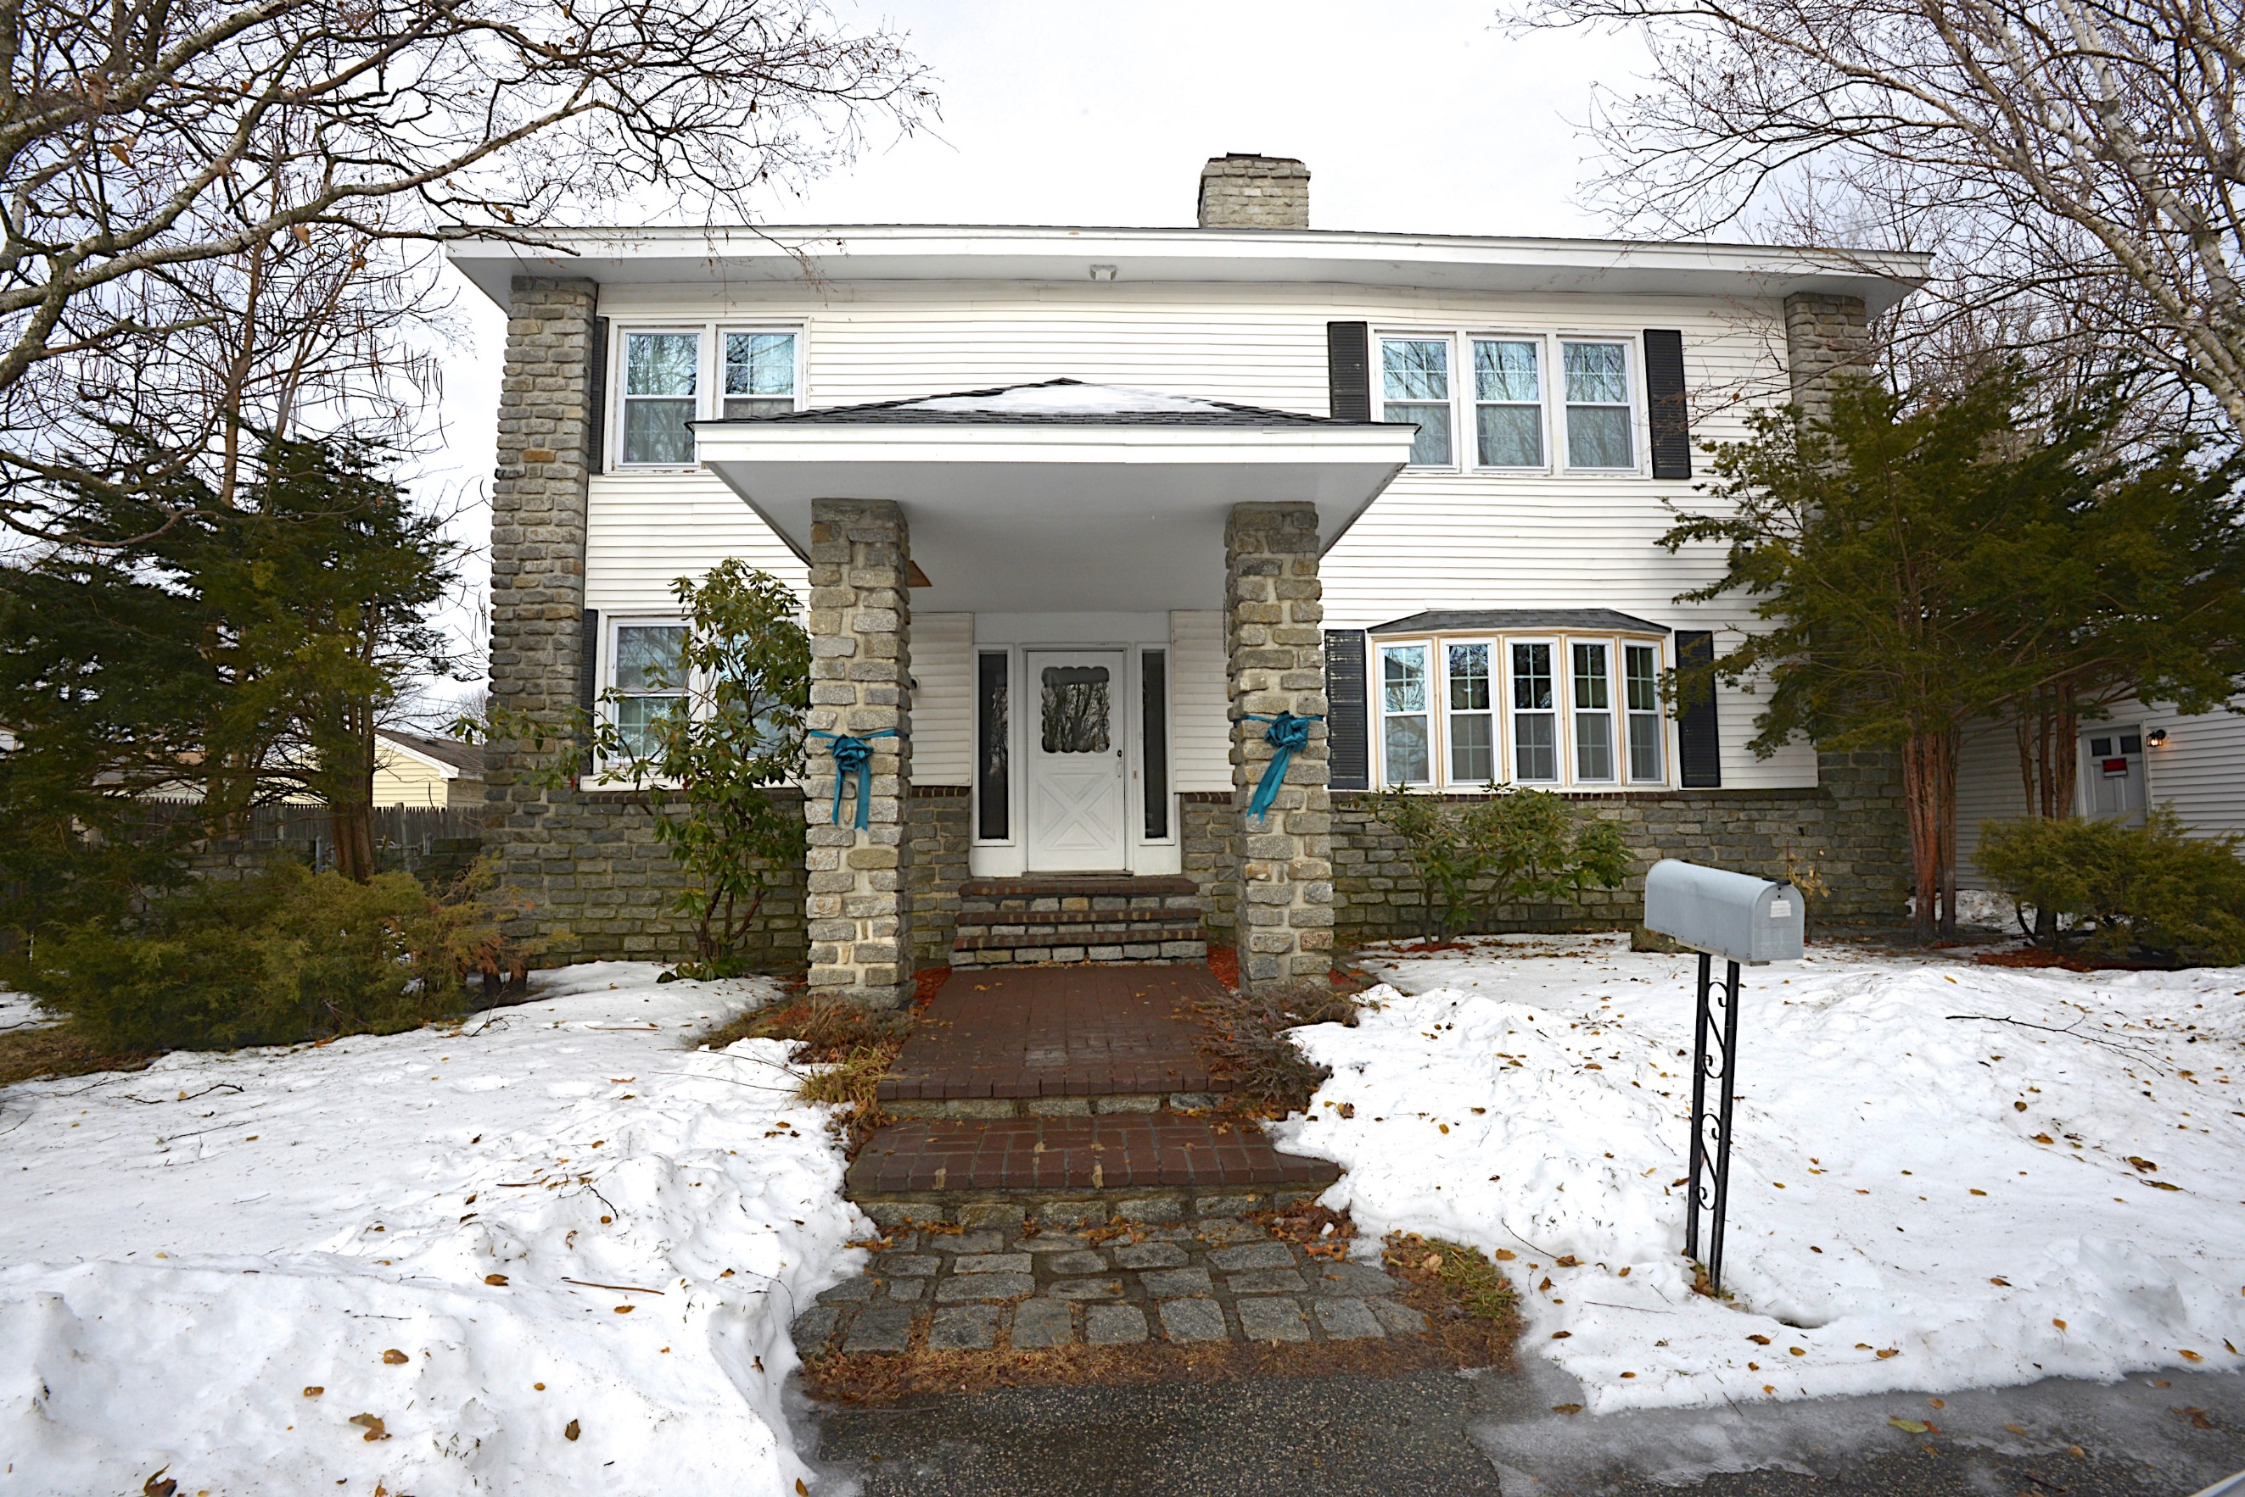

Zack’s House – Lowell, MA

Zack's Team Foundation is a recognized, established 501(c)(3) non-profit. All proceeds from this event provide treatment scholarship funds for young adults, providing hope to them and their families.

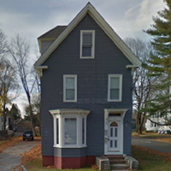

Zack’s House – Portland, ME

**CHECK APPLICABLE OPTION:**

* Recovery Champion - $5,000
* Recovery Ambassador - $2,500
* Recovery Ally - Beverage Cart - $1,000
* Recovery Ally - Lunch Sponsor - $1,000
* Triple Tee Sponsor - $500
* Tee Sponsor - $250
* Friend of Zack - $100
* Raffle Item

REGISTRATION FORM

Thank you for your interest in supporting Zack’s Team’s 6th Annual Links fore Recovery Golf Tournament to be held Tuesday, August 20, 2019 at Four Oaks Country Club in Dracut, Massachusetts. If you are able to join us, a BBQ lunch and **registration will be begin at 11:00 AM and tee off begins at 12 PM**. Dinner will be served at the conclusion of the tournament and dinner only guests are invited to join us at 5:30 PM. If you have any questions, please contact Taylor at [zacksteams818@gmail.com](mailto:zacksteams818@gmail.com) or visit our website [www.zacksteam.org](http://www.zacksteam.org) . This event is sure to sell out, so register early!

**Credit Card Information:**

Name on Card: ___________________________

Card Number: ___________________________

Billing Zip Code: ___________________________

Exp. Date: __________ Security Code: _________

Signature: ______________________________

**Checks can be made payable to:**

Zack’s Team - 50 Tower Farm Road Billerica, MA 01821

Sponsor logo’s and completed forms may be emailed to Taylor at [zacksteam818@gmail.com](mailto:zacksteam818@gmail.com) or mailed to 50 Tower Farm Road, Billerica, MA 01821

SPONSOR NAME: _______________________________________________________

CONTACT PERSON NAME: ________________________________________________

ADDRESS: ____________________________________________________________

PHONE: __________________________ EMAIL: ___________________________